Chapter 8, Solution 8.

Design a problem to help other students better understand source-free RLC circuits.

Although there are many ways to work this problem, this is an example based on the same kind of problem asked in the third edition.

Problem

The branch current in an RLC circuit is described by the differential equation

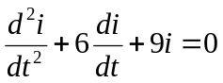

and the initial conditions are i(0) = 0, di(0)/dt = 4. Obtain the characteristic equation and determine i(t) for t > 0.

Solution

s² + 6s + 9 = 0, thus s_{1,2} = 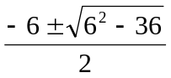 = -3, repeated roots.

i(t) = [(A + Bt)e^{-3t}], i(0) = 0 = A

di/dt = [Be^{-3t}] + [-3(Bt)e^{-3t}]

di(0)/dt = 4 = B.

Therefore, i(t) = [4te^{-3t}] A

